

**Lab Report**

**Course Title:** Big Data And IOT

**Course Code:** CSE413

**Report No:** 01

**Report Title:** Hadoop Installation On My_NativeOS[Linux]

**Submitted To:**

**Name: Husne Mubarak**

**Designation: Lecturer**

**Dept. of Computer Science and Engineering**

**Daffodil International University**

**Submitted By:**

**Name: Md Shamsuzzaman**

**ID: 211-15-4031**

**Section: 58_E(E1)**

**Department Of CSE**

**Daffodil International University**

**Date of Submission: 24 - 04 – 2024**

**Title:** Installation of Linux, JDK and Hadoop in Virtual Box/Linux

**Description:** At First install JavaJDK or If it is installed then check the version and path.

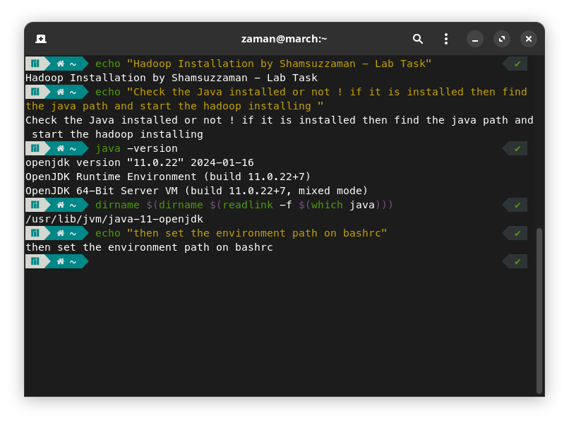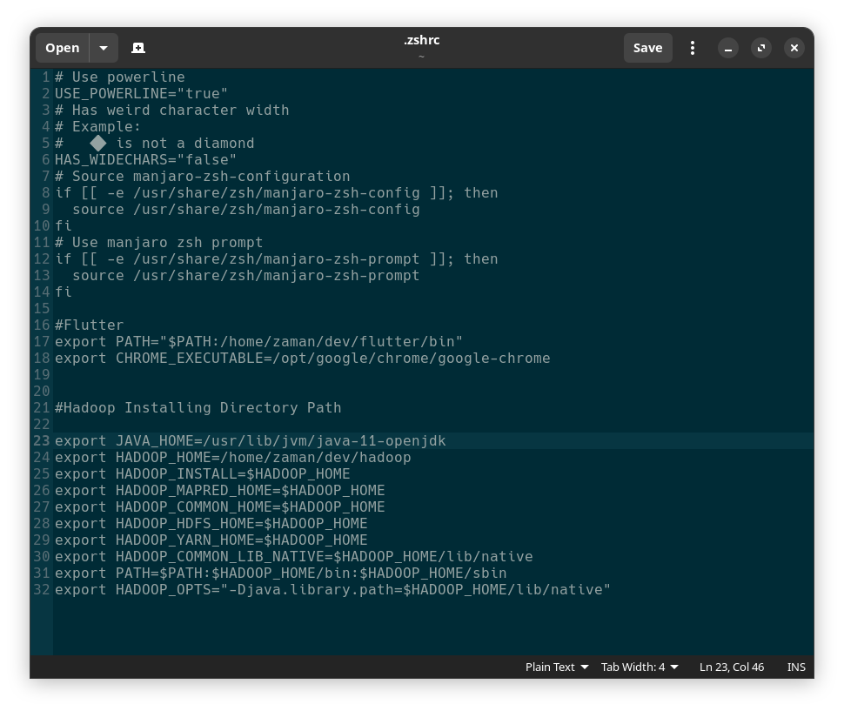

Edit .Zshrc like above.

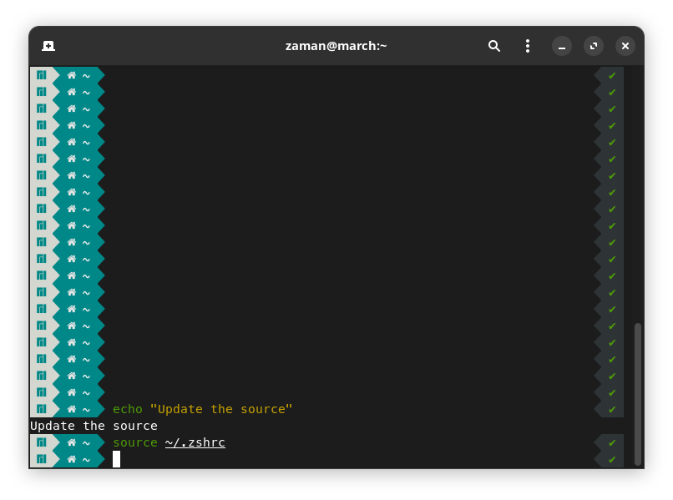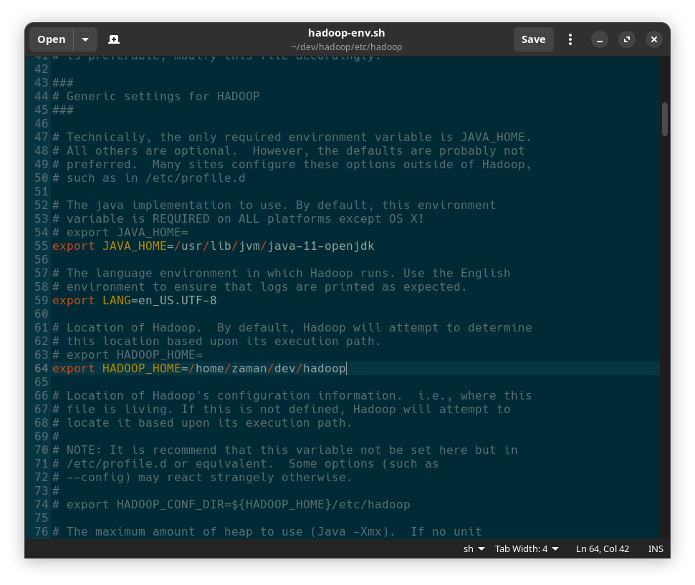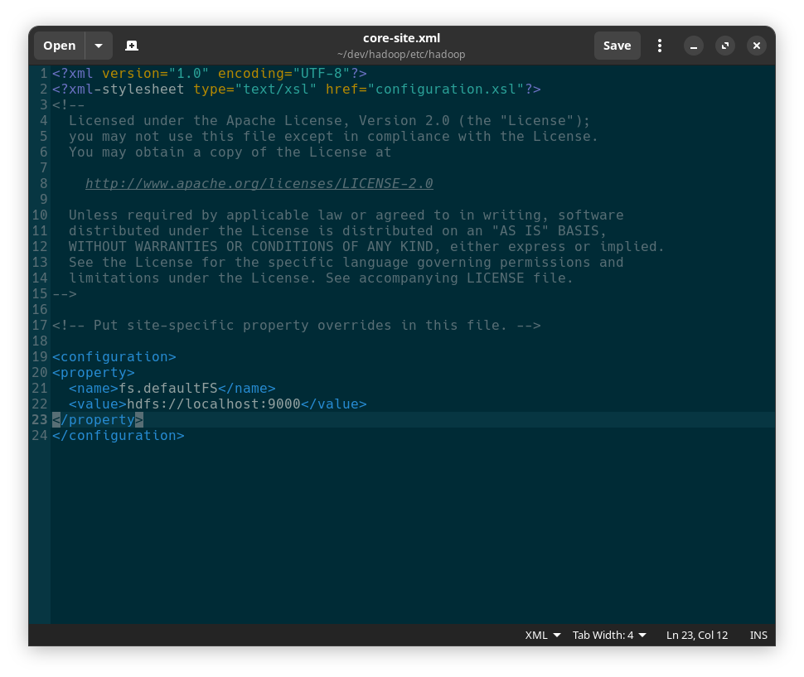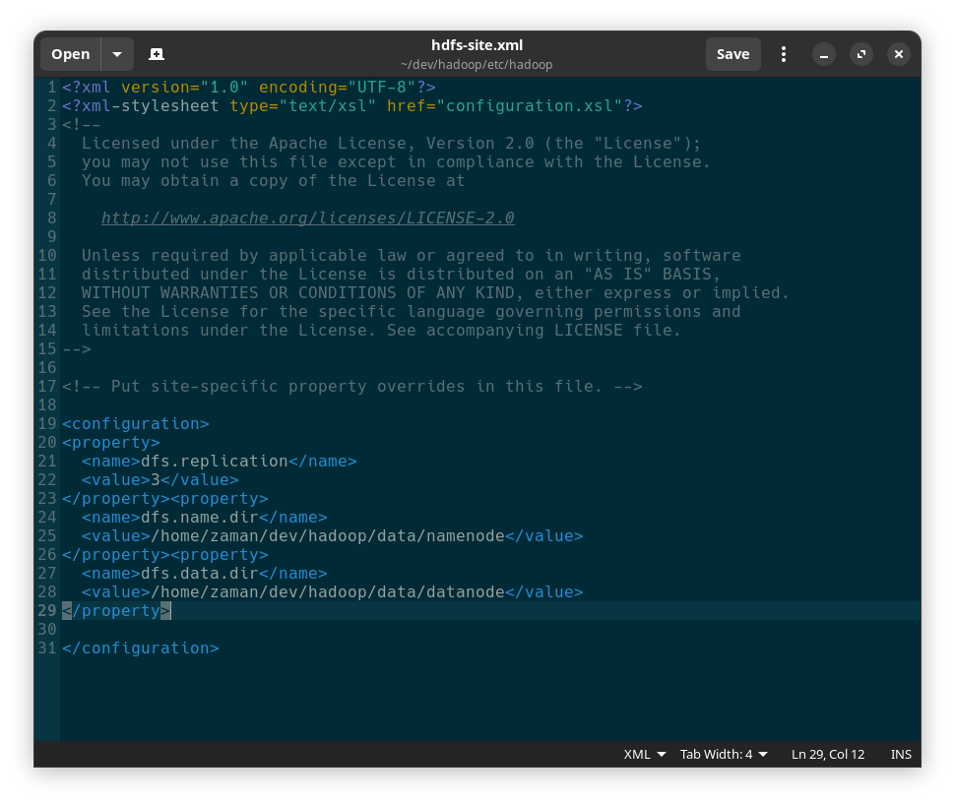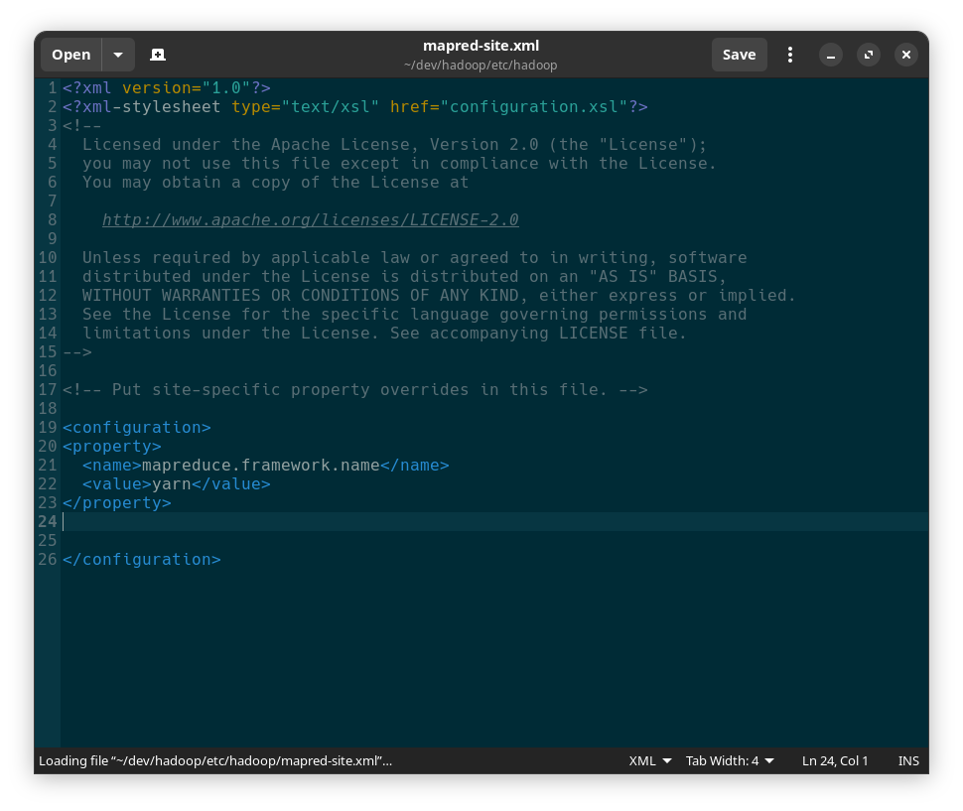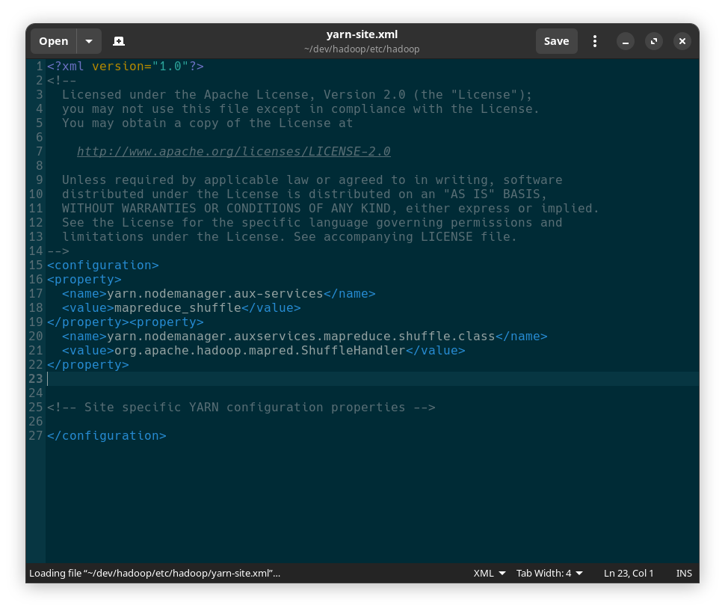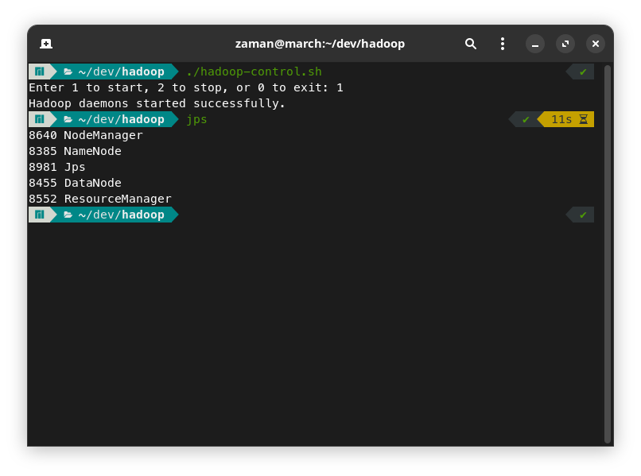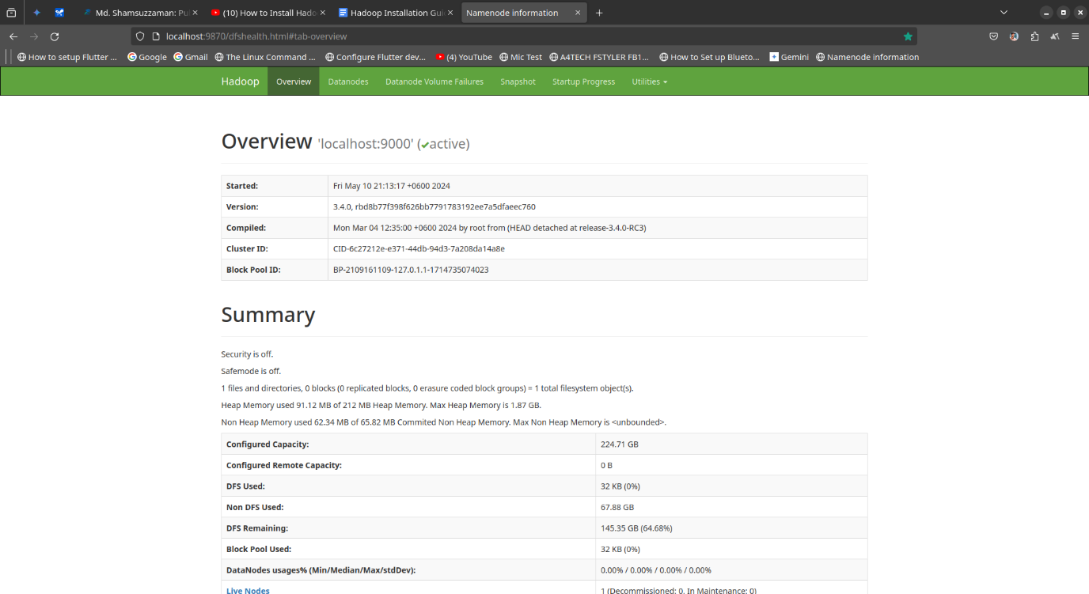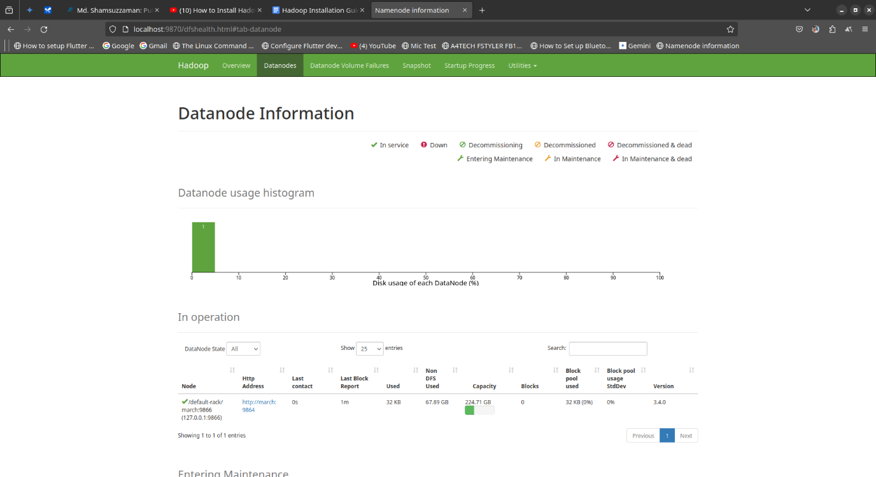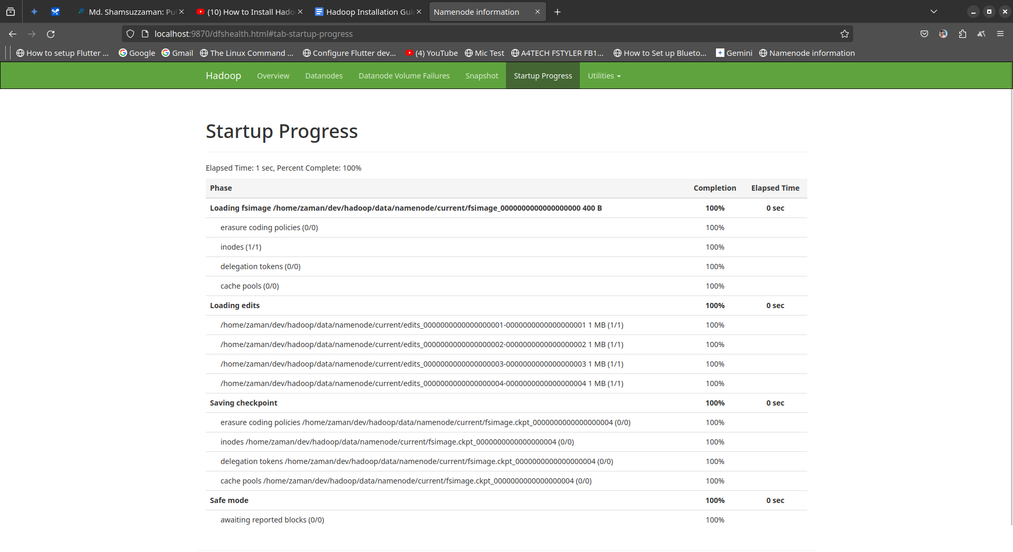

All My command:

# Find Java Location Command

dirname $(dirname $(readlink -f $(which java)))

Output:

/usr/lib/jvm/java-11-openjdk

# For bashrc

export JAVA_HOME=/usr/lib/jvm/java-11-openjdk

export HADOOP_HOME=/home/zaman/dev/hadoop

export HADOOP_INSTALL=$HADOOP_HOME

export HADOOP_MAPRED_HOME=$HADOOP_HOME

export HADOOP_COMMON_HOME=$HADOOP_HOME

export HADOOP_HDFS_HOME=$HADOOP_HOME

export HADOOP_YARN_HOME=$HADOOP_HOME

export HADOOP_COMMON_LIB_NATIVE=$HADOOP_HOME/lib/native

export PATH=$PATH:$HADOOP_HOME/bin:$HADOOP_HOME/sbin

export HADOOP_OPTS="-Djava.library.path=$HADOOP_HOME/lib/native"

## Hadoop Configuration

# For core-site.xml

<property>

  <name>fs.defaultFS</name>

  <value>hdfs://localhost:9000</value>

</property>

# For hdfs-site.xml or https-site.xml

<property>

  <name>dfs.replication</name>

  <value>3</value>

</property><property>

  <name>dfs.name.dir</name>

  <value>/home/zaman/dev/hadoop/data/namenode</value>

</property><property>

  <name>dfs.data.dir</name>

  <value>/home/zaman/dev/hadoop/data/datanode</value>

</property>

# For mapred-site.xml

<property>

  <name>mapreduce.framework.name</name>

  <value>yarn</value>

</property>

# For yarn-site.xml

<property>

  <name>yarn.nodemanager.aux-services</name>

  <value>mapreduce_shuffle</value>

</property><property>

  <name>yarn.nodemanager.auxservices.mapreduce.shuffle.class</name>

  <value>org.apache.hadoop.mapred.ShuffleHandler</value>

</property>

hdfs namenode -format

start-dfs.sh

# SSH Key Configure

ssh-keygen -t rsa

# replace id_rsa as authorized keys

cat ~/.ssh/id_rsa.pub >> ~/.ssh/authorized_keys

# add read and write access

chmod 640 ~/.ssh/authorized_keys

sudo systemctl enable sshd

sudo systemctl start sshd

#!/bin/bash

# Start individual daemons

sbin/hadoop-daemon.sh start namenode

sbin/hadoop-daemon.sh start datanode

sbin/yarn-daemon.sh start resourcemanager

sbin/yarn-daemon.sh start nodemanager

# Add additional daemons if needed based on your configuration

echo "Hadoop daemons started successfully."

#!/bin/bash

# Stop individual daemons

sbin/hadoop-daemon.sh stop namenode

sbin/hadoop-daemon.sh stop datanode

sbin/yarn-daemon.sh stop resourcemanager

sbin/yarn-daemon.sh stop nodemanager

# Add additional daemons if needed based on your configuration

echo "Hadoop daemons stopped successfully."

#!/bin/bash

function start_daemons {

  # Start daemons using recommended 'hdfs' and 'yarn' commands

  hdfs --daemon start namenode

  hdfs --daemon start datanode

  yarn --daemon start resourcemanager

  yarn --daemon start nodemanager

  # Add additional daemons if needed

  echo "Hadoop daemons started successfully."

}

function stop_daemons {

  # Stop daemons using recommended 'hdfs' and 'yarn' commands

  hdfs --daemon stop namenode

  hdfs --daemon stop datanode

  yarn --daemon stop resourcemanager

  yarn --daemon stop nodemanager

  # Add additional daemons if needed

  echo "Hadoop daemons stopped successfully."

}

# Main loop for user interaction

while true; do

  read -p "Enter 1 to start, 2 to stop, or 0 to exit: " choice

  case $choice in

1)

   start_daemons

   break

   ;;

2)

   stop_daemons

   break

   ;;

0)

   echo "Exiting..."

   exit 0

   ;;

*)

   echo "Invalid choice. Please enter 1, 2, or 0."

   ;;

  esac

done

# Make the script executable (optional)

#chmod +x hadoop-control.sh